**MACHINE LEARNING COURSE 1**

**WEEK#1:**

>> TYPES OF ML ---> Supervised ML(use mostly in real world app) and Unsupervised ML

>> SUPERVISED ML ===> input(x) -> output(y) --> (Right answers are known already) --> Example --> House Price Prediction

>> Types of Supervised Learning:

(Regression --> Infinite no. of Outputs, And output will be Numeric ),

(Classification --> Breast Cancer Detection --> Finite no.of output ) --> Classification predicts categories which can be non-numeric and more than one or two

>> UNSUPERVISED ML ===> To take the data set and find some interesting things or structure (To make groups or cluster) -->

>> Types: Example --> Google News of Pandas ( Right answer is not known in advance ) ---> Data is without labeling ----> One of its type is Clustering -->

Other are Anomoly Detection ( To detect unusual events ) and other one is Dimensionality Reduction ( To compress a large data set to a smaller )

>> NOTATIONS:

Training Set ---> Data graph or table which is given to machine to learn

x --> Input or Feature

y --> Output or Target

m --> Total no. of traning examples

(x,y) ---> Single training example

(x(exp-sub)i,y(exp-sub)i) ---> Particular training example in ith row (like record) (exp = exponential) (i = index)

sub ==> Subscript

>> UNIVARIANT LINEAR REGRESSION ---> One Variable Linear Regression

f = function / hypothesis --> f is called Model

w,b ==> Parameters / Coefficients / Weights

y^ = output / prediction ---> Conventionally y^ (y hat) is prediction or estimation for y (actual target / output value)

f(sub w b)(x) = wx + b -----> w on x-axis and b on y-axis -----> model training function

w: Weight or coefficient for the independent variable. This value represents the slope of the linear relationship between the independent variable and the dependent variable. It determines how much the dependent variable (often denoted as y) changes for a unit change in the independent variable.

b: Bias term, also known as the intercept or constant. This is the value of the dependent variable y when the independent variable x is zero. It represents the y-intercept of the linear equation and the value of y when there is no contribution from x.

In univariate linear regression, you are trying to find the best values for w and b that minimize the error between the predicted values and the actual values in your dataset.

y --> Original Output(That is obtained when e.g the House is sold) and y^ is estimated output ( Guess after drawing line using Regression)

>> COST FUNCTION (J) / MEAN SQUARE ERROR FUNCTION:

J(w, b) = sum from 0 to m ( y^ - y(exp-sub i))^2 = error for Ith instance ===> To find average error divide it by m (total # of trining examples) or by 2m as use in ML to get better results ---> >>>> Lecture 12 <<<<

>> f_w(x) --> For fixed w it is function of input feature x.

J(w) ---> Function of parameter w

**>> FUNCTION TO CALCULATE THE COST IN LABS:**

def compute_cost(x, y, w, b):

m = x.shape[0]

cost = 0

for i in range(m):

f_wb = w * x[i] + b

cost = cost + (f_wb - y[i])**2

total_cost = 1 / (2 * m) * cost

return total_cost

**>> MINIMIZE ( w OF b) WHICH IS COST FUNCTION:**

>> "min" stands for "minimum," indicating that you are trying to find the smallest possible value of something.

>> "w" often represents the weights in a machine learning or optimization context. These weights are numerical values associated with the input features or neurons in a neural network. The cost function depends on these weights, and you want to find the set of weights that minimizes the cost function.

>> "b" usually represents "BIASES" in machine learning. Biases are additional parameters in a model that allow it to fit data more flexibly. Like weights, biases also affect the cost function, and you want to find the biases that result in the minimum cost.

>> First we take b=0 to determine the values of J(w) which is Mean Square Error Function for different values of w ==> This will help to find the w value which best fits the data ==> When there was only "w", the J(w) was simply a u-shaped/parabola type curve.

>> Then we take b!=0 to determine the values of J(w) which is Mean Square Error Function for different values of w and b ==> This will help to find the w and b value which best fits the data ==> When there was only "w", the J(w) was simply a u-shaped/parabole type curve, but now J(w) is Bowl like shape

>> There are 2 ways to DRAW THE DATA POINTS GRAPH:

1) 3D plot where height gives value of J

2) Contours plot every horizontal piece is at same height. Center of all ellipses gives minimum cost function value

**>>** **GRADIENT DESCENT(GENERAL)** --> A model to minimize the cost function. It has many other uses as well.

>> In graph of J_w,b, it starts looking in **360 degree** and go to nearest steepest point which has less cost. The lower point obtain there is LOCAL OPTIMA as we can't go through that path from other hills to plain area optimally.

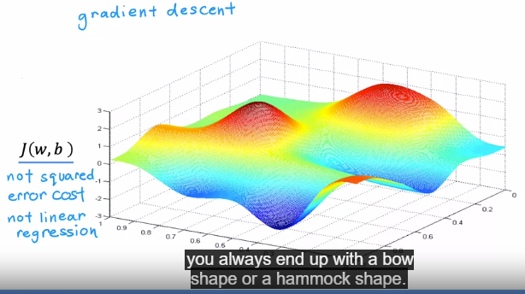

**>>** **GRADIENT DESCENT FOR LINEAR REGRESSION MODEL:**

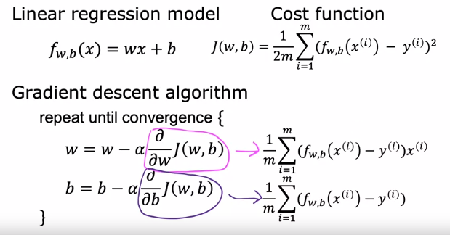

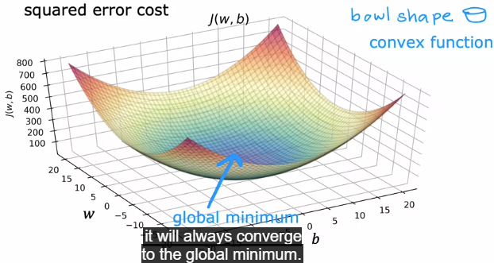

**But it turns out when you're using a squared error cost function with linear regression, the cost function does not and will never have multiple local minima. It has a single global minimum because of this bowl-shape. The technical term for this is that this cost function is a convex function. Informally, a convex function is of bowl-shaped function, and it cannot have any local minima other than the single global minimum.**

>> FORMULA ---> w = w − α * ∂/∂w J(w,b) ---> Here ALPHA (Learning Rate) means how big the step cost to hill down.

>> Here PARTIAL DER is use to determine in which DIRECTION the baby step has to be taken.

>> For "b" --> b = b − α * ∂/∂b J(w,b)

>> The above two functions keep repeating until there is **convergence** (means you reach the local minimum where the step taken don't change w and b anymore)

>> SIMILTANEOUS UPDATE ---> Its important to do simultaneous update of the value of "w" and "b" at one time **use the previous value of "w" and "b" to run** the above both functions. Not use the update value of "w" at same time in function of "b" as it is INCORRECT way.

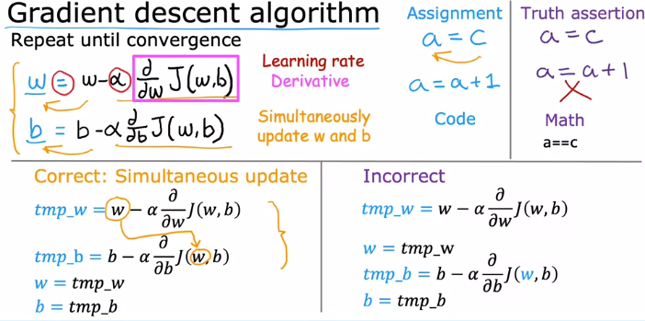

>> partial der == "d" symbol

**>> HOW PARTIAL DER HELPS IN MINIMIZE:** "w" ---> LECTURE#17 Gives intuition how the PARTIAL DER changes the "w" to give optimized "w" by adding and subtracting alpha times an integer from previous "w"

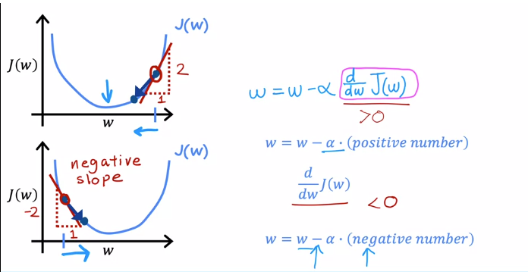

**>> HOW PARTIAL DER HELPS IN MINIMIZE "ALPHA" AND CASES OF SMALL AND LARGE ALPHA** ---> LECTURE#18 explains different cases of alpha value. One IMPORTANT thing is that if you are already on the local minima then the GRADIENT DESCENT will not move the points as at that point TANGENT IS STRAIGHT LINE WHICH HAS SLOPE=0 means (∂/∂w J(w)=0), so " w - alpha . 0 = w". It is because at the local minimum, the derivative (slope) of the cost function with respect to the parameters is zero.

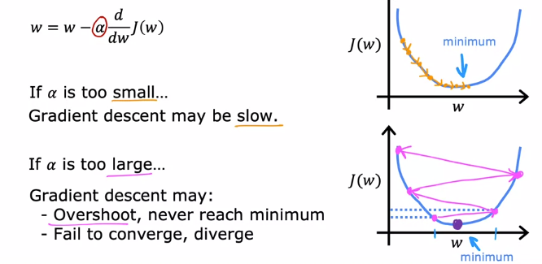

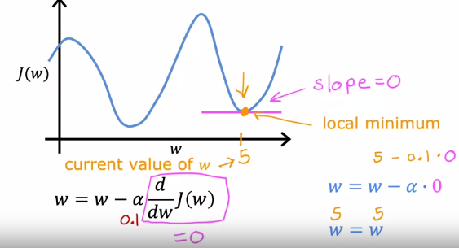

**>> SOLUTION OF ABOVE PROBLEM** ---> Its solution is that algorithm should take large step means large alpha when it is far from local minima and becomes small as it reaches near the local minima ---> It is done automatically as PARTIAL DER is large when path is steeper which is when point is far from MINIMA and vice versa.

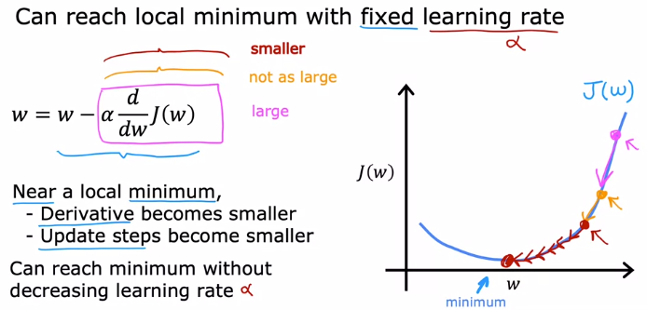

**>> GRADIENT DESCENT FOR LINEAR REGRESSIN (USING COST FUNCTION --> MEAN SQUARED ERROR):**

🡪 LECTURE#19 gives DERIVATION/EXPLAINATION of above partial der equations. GRADIENT DESENT has more than one LOCAL MINIMA while MEAN SQUARED ERROR (Having BOWL shape also known as CONVEX FUNCTION) has only one GLOBAL MINIMA.

>> MSE is "bowl shaped" because its cost function is calculated using just the ACTUAL COST (y) and PREDICTED COST (y^) so it has convex shape while GRADIENT DESCENT cost function uses the "w" and "b" parameters, so it gives 3D interface.

>> Now the input features are "w and b" but instead of taking 3D view of cost function, we take 2D view of the cost function which is convex function as it is helpful in finding the GLOBAL MINIMA.

**>> BATCH GRADIENT DESCENT:**

>> LECUTURE#20 ---> Each step of gradient descent uses all the training examples to find a good global minima.

**WEEK#2:**

**>> LINEAR REGRESSION WITH MULTIPLE INPUTS:**

NOTATIONS:

>> Now parameters and inputs become vectors like:

* + - x^-> (read as x arrow = vector x) and w^->
    - x^-> = [x1, x2 .... xn ] ==> vector set of input features
    - w^-> = [w1,w2 .... wn] ==> vector set of parameters,
    - b is a number not a vector element
    - x subscript j = jth column feature
    - x superscript i = ith example
    - dot product of vector w and x

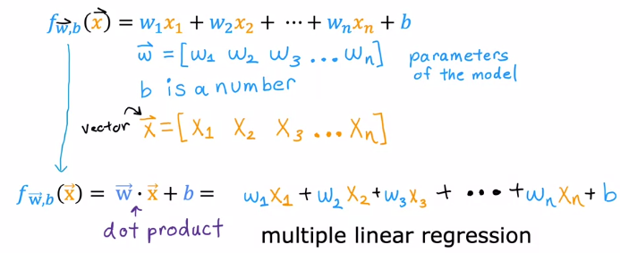

**>> VECTORIZATION PART-1:**

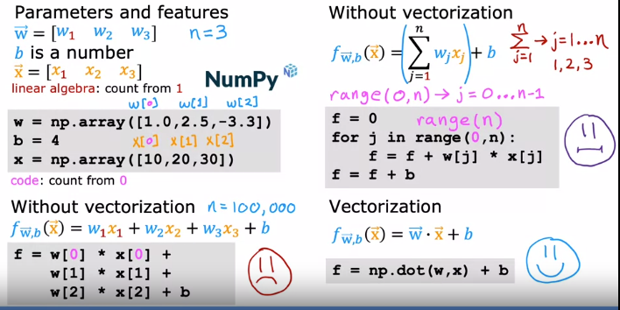

**>> VECTORIZATION PART-2:**

Procedure is given below:

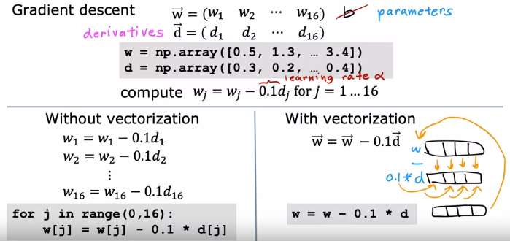

**>> GRADIENT DESCENT FOR MULTIPLE LINEAR REGRESSION:**

Gradient descent for multiple features on right side and for one feature on left side:

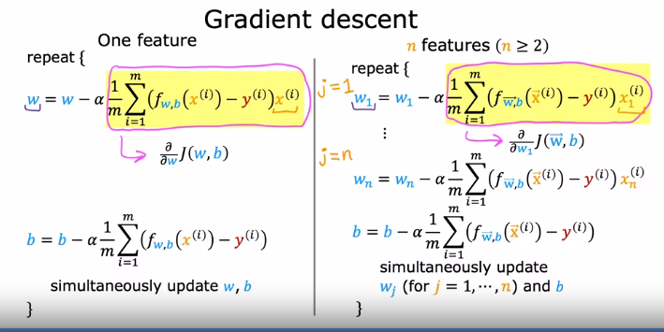

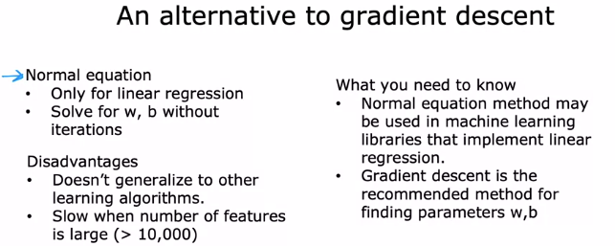

**>> FEATURE ENGINEERING:**

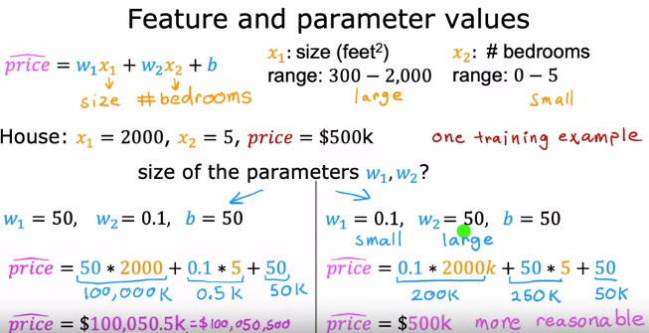

**>> FEATURE ENGINEERING 2:**

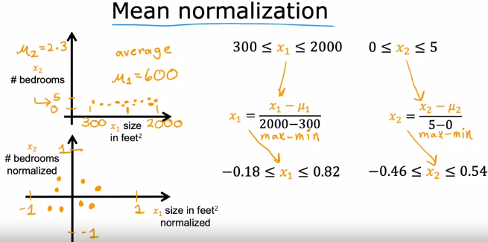

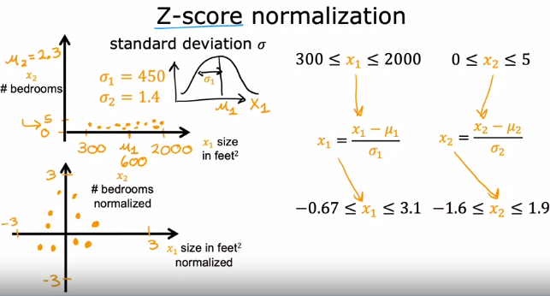

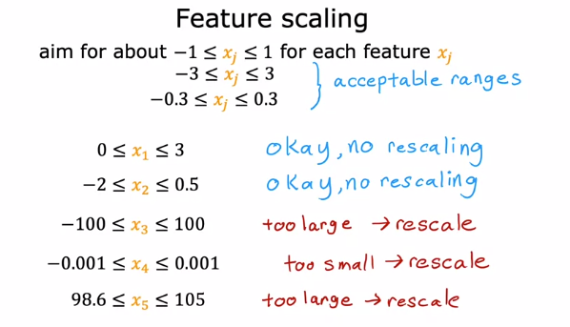

**>> Learning Rate (Alpha and Convergence Test):**

>> Your learning algorithm will run much better with an appropriate choice of learning rate. If it's too small, it will run very slowly and if it is too large, it may not even converge.

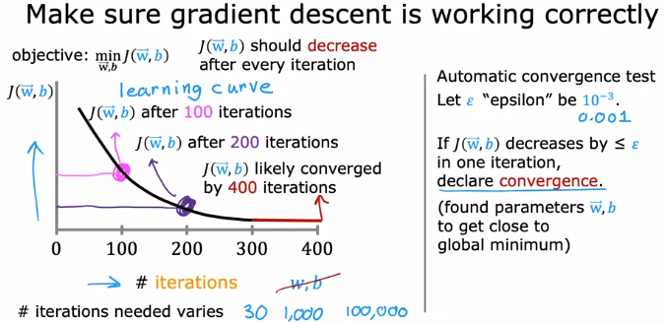

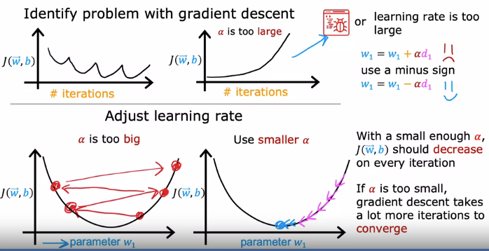

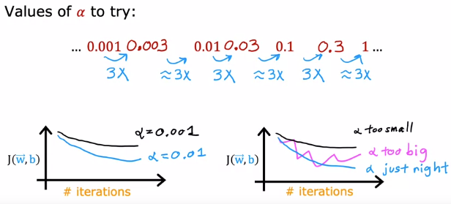

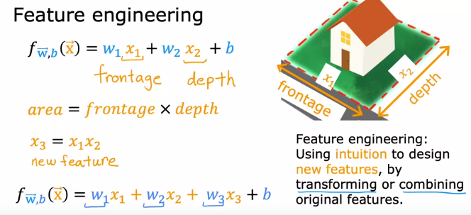

**>>POLYNOMIAL REGRESSION:**

>>Maybe you want to fit a curve, maybe a quadratic function to the data like this which includes a size x and x squared, which is the size raised to the power of two. Maybe that will ive you a better fit to the data. But then you may decide that your quadratic model doesn't really make sense because a quadratic function eventually comes back down. Well, we wouldn't really expect housing prices to go down when the size increases. Big houses seem like they should usually cost more. Then you may choose a cubic function where we now have not only x squared, but x cubed.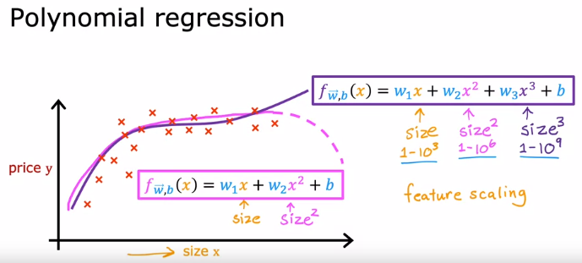

**WEEK#3:**

**>> LOGISTIC REGRESSION:**

🡪 It is used for classification. Don’t confuse it with the word regression as used in it.

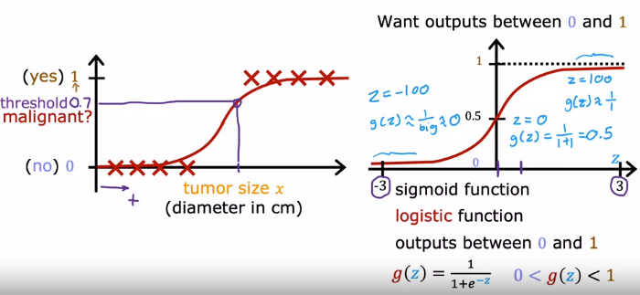

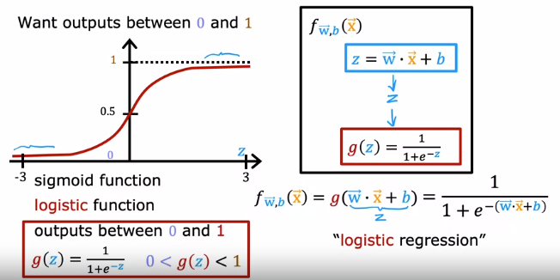

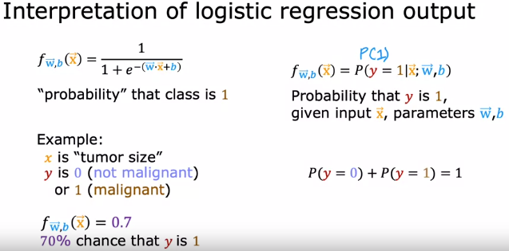

**>> DECISION BOUNDARY:**

🡪To recap, here's how the logistic regression model’s outputs are computed in two steps. In the first step, you compute **z** as w.x plus b. Then you apply the **Sigmoid function** **g** to this value z. Here again, is the formula for the Sigmoid function. 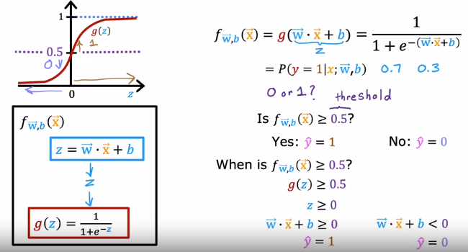

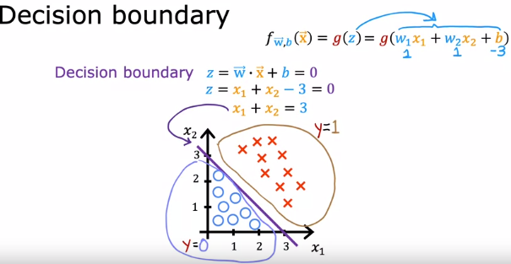

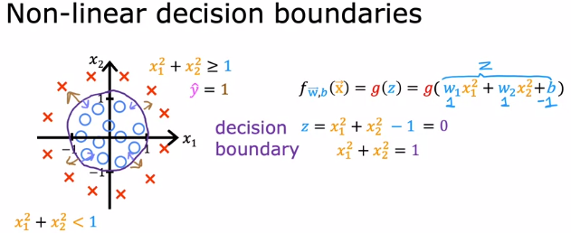

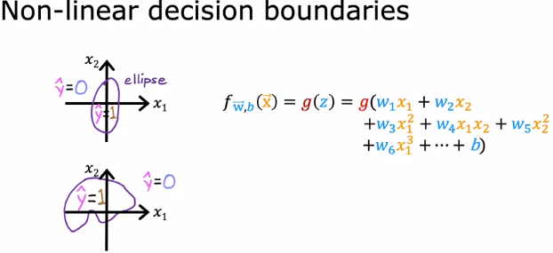

**>> COST FUNCTION:**

* Cost function for logistic regression is different from linear regression.

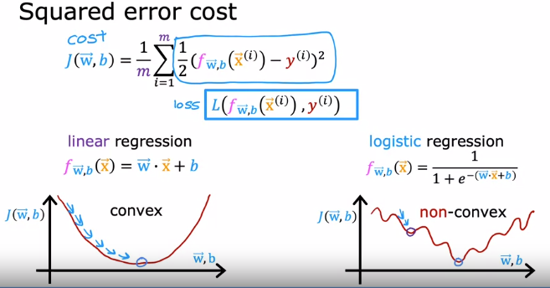

* Now here, **f** is the output of **logistic regression**. Thus, f is always between zero and one because the output of logistic regression is always **between zero and one**. The only part of the function that's relevant is therefore this part over here, corresponding to f between 0 and 1.
* On **x-axis** we have **f** (output of log-reg) and on **y-axis** there is loss function **L**.

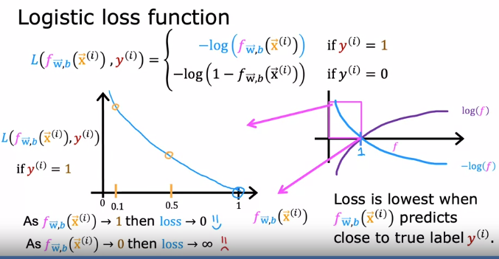

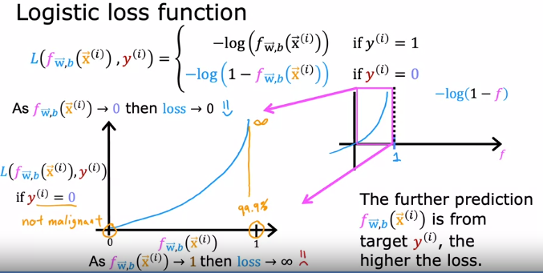

* Total cost is the **sum of loss on all the training examples** like in mean squared error function but here only LOSS Function changes remaining procedure is same.

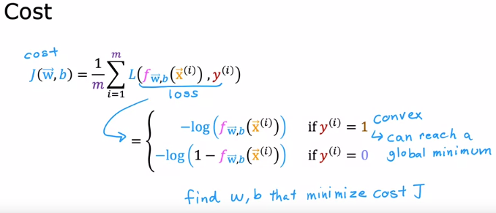

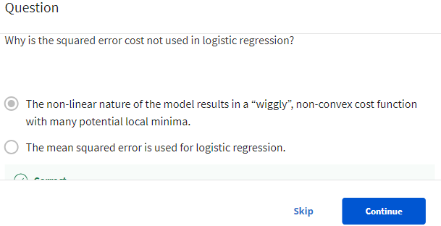

**>> SIMPLIFIED COST FUNCTION:**

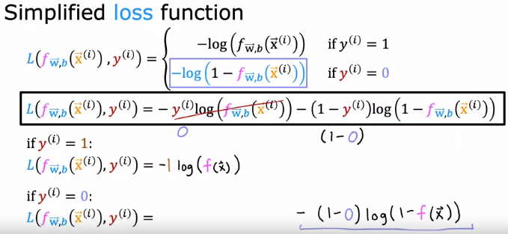

* This cost function is not written directly but after statistical research it shows that this function will give good parameters (w, b etc) by using a technique called **Maximum Likelihood**.

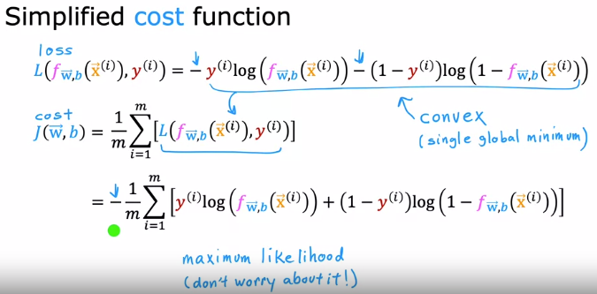

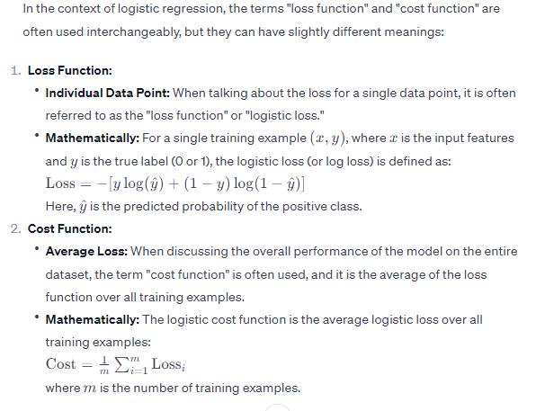

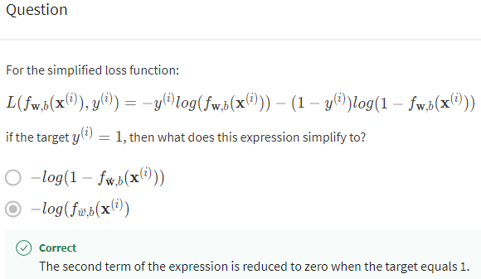

**>> GRADIENT DESCENT FOR LOGISTIC REGRESSION:**

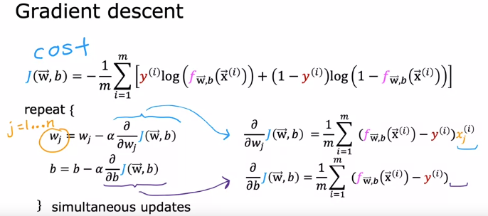

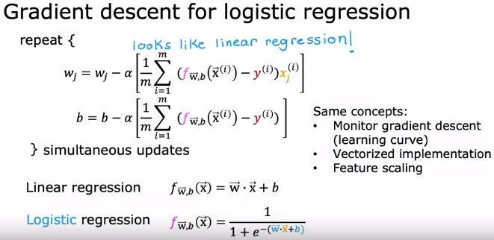

**🡪** Like the discussion on vectorized implementations of linear regression, you can also use vectorization to make gradient descent run faster for logistic regression.

**>> PROBLEM OF OVERFITTING:**

**🡪** To recap, if you have **too many features** like the fourth-order polynomial on the right, then the model may fit the training set well, but almost **too well or overfit** and have high variance. On the flip side if you have **too few features**, then in this example, like the one on the left, it **underfits and has high bias**. In this example, using quadratic features x and x squared, that seems to be just right.

* Overfitting is called high variance because it occurs when a model learns the training data too well, capturing noise and random fluctuations rather than the underlying pattern. As a result, the model performs well on the training data but fails to generalize to new, unseen data.
* The term "biased" reflects the model's inadequate representation of the underlying complexities in the data.

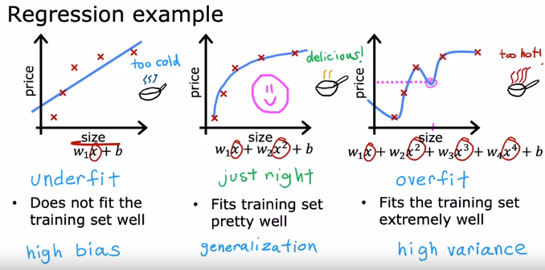

**>> ADDRESSING OVERFITTING:**

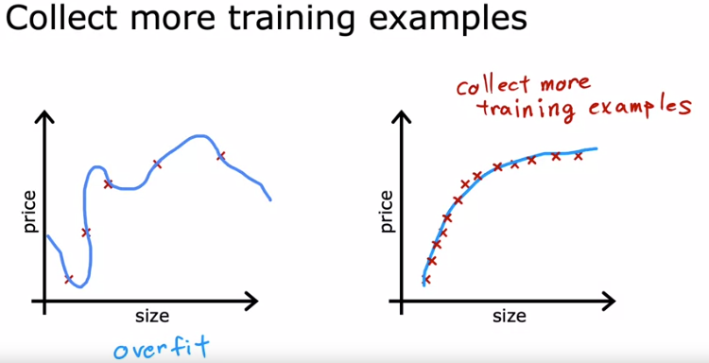

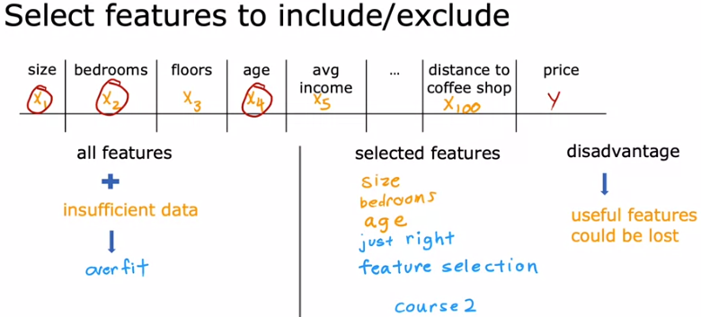

* By the way, by convention, we normally just reduce the size of the **wj** parameters, that is **w1 through wn**. It doesn't make a huge difference whether you regularize the parameter **b** as well, you could do so if you want or not if you don't. I usually don't and it's just fine to regularize w1, w2, all the way to wn, but not really encourage **b** to become smaller.

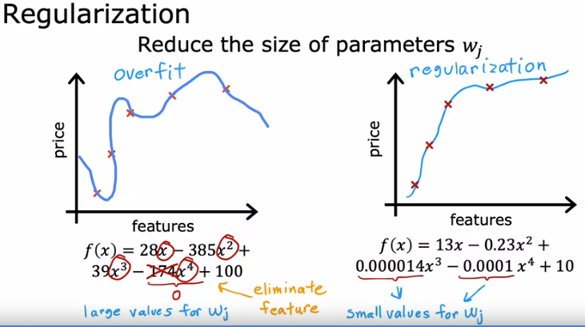

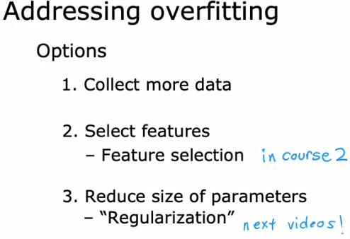

**>> COST FUNCTION WITH REGULARIZATION:**

* Here's the idea behind **regularization**. The idea is that if there are smaller values for the parameters, then that's a bit like having a simpler model. Maybe one with fewer features, which is therefore less prone to overfitting.

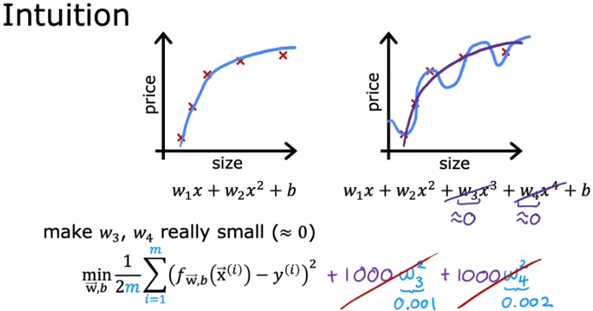

* Penalizing refers to the practice of imposing a penalty or cost on certain aspects of a model to discourage undesirable behavior. This is commonly done through regularization techniques in machine learning models.

**For example,** L1 and L2 regularization add penalty terms to the model's optimization objective based on the magnitude of the model parameters. This helps prevent overfitting by discouraging the model from assigning too much importance to any one feature (L1 regularization) or by limiting the overall magnitude of the parameters (L2 regularization).

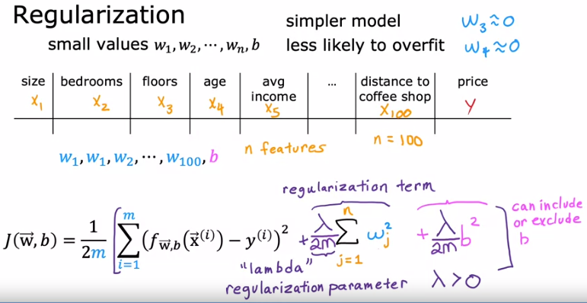

* If **b** will be too large, then model will underfit the data.

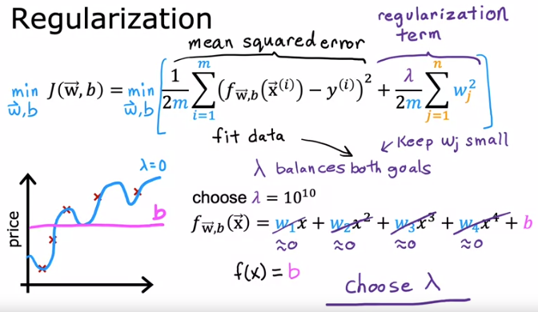

**>> REGULARIZED LINEAR REGRESSION:**

* Here Is a cost function we've come up with in the last video for regularized linear regression. The first part is the usual squared error cost function, and now you have this additional regularization term, where Lambda is the regularization parameter, and you'd like to find parameters w and b that minimize the regularized cost function.

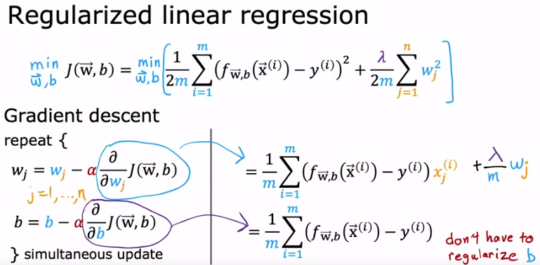

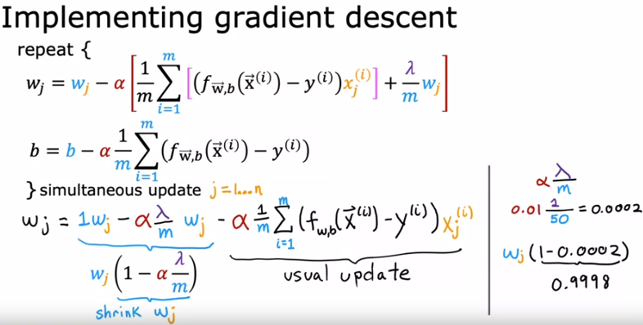

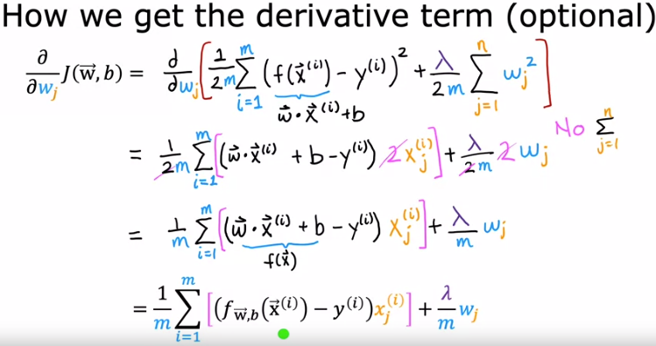

**>> REGULARIZED LOGISTIC REGRESSION:**

